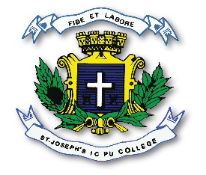
ST. JOSEPH’S INDIAN COMPOSITE PU COLLEGE
#23, Vittal Mallya Road, Bangalore – 560001.

SUBJECT: PHYSICS (33)
II PUC
SYLLABUS FOR I TEST – 2023-24

Chapters - 1. Electric Charges & Fields,
2. Electric potential and capacitors,
3. Current electricity.
4. Moving charges and magnetism ( Upto the derivation of
Magnetic Field at a point along the axis of a circular current
loop Biot-Sarvat’s Law )

